Certificate in Information Technology

Computer Essentials (CT423) System Components – Lab 1

Lab Background:
Using the World Wide Web you are required to identify the components of five computer systems. The systems chosen should meet the needs of an average household.

For each system identify: CPU type and speed, RAM type and amount, Size of Hard Drive, Graphics details, Audio details, Optical Drives (CD, DVD), Expansion Slots, Screen type, Bundled Software.

Write up a report that includes each system’s details, as well as a summary paragraph on which system is your favourite and why.

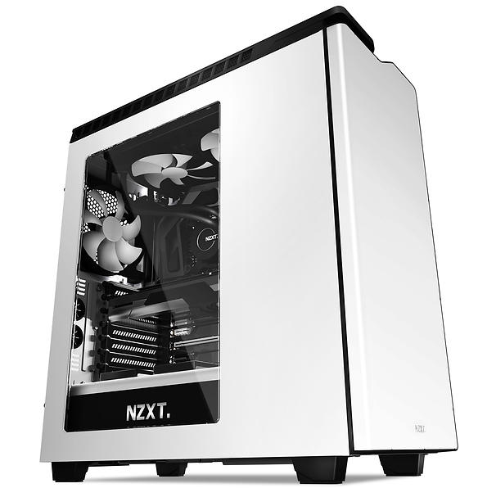
My Gaming PC

AMD FX-Series FX-8350 4.0GHz Socket – CPU
Gigabyte GA-990FXA-UD3 – Motherboard
Kingston HyperX Fury White DDR3 PC15000/1866MHz
CL10 2x4GB – RAM
Corsair CS850M 850W – Power Supply
1TB 7200 RPM SATA 6GB/s – Hard Drive
Gigabyte Radeon R9 290X HDMI DP 2xDVI 4GB
NZXT H440 White/Black – Case
Corsair Hydro H55 – Water Cooling
NZXT Kraken G10 Bracket (White)
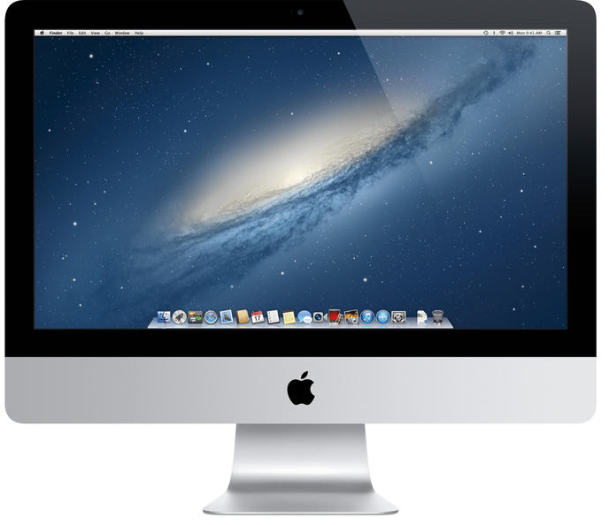

Apple IMac

Intel Core i5 4570 Quad core – CPU
8GB DDR3 – RAM
GeForce GT 755M GDDR5 1,024 MB
16:9 (widescreen) 2560x1440 27 inch

